Literature Review
Cynthia Wade
Dr. Brandy Goldston
PSY 610 Applied Social Psychology
08/04/2017

Literature Review
For a long time now society has been clear of blame when individuals develop characters that are questionable. A lot of people when criminals are caught blame it on the financial situation of the offender as the reason why the offender engaged in crime whereas others blame it on the economic situation of the country and others blame it on poor policing by the disciplined forces to ensure that crime is stamped out of a locality or a region (Assink et. al, 2015). However after a close research I would like to believe otherwise. So is a person’s character really determined by the morals of the society that they came from or their behavior is influenced by the economic situation of a country that they are in, that is what this paper is about to discover.
Analysis
According to (Punyasavatsut, 2016), he states that the crime rates that are experienced in a country are directly related to the economic condition of the country. He states that most criminals are people who have been frustrated emotionally because they have always lacked what they need in life. For this reason, they have always ended up looking for it by force. He goes on to give an example by saying that the reason why a carjacker would steal a car, is because he needs money. If the same carjacker had a car, he would not have gone into stealing; instead he would take his car and resell it so that he could be able to make profit out of it. His idea is supported by (Park, Kim & Mi-Seon, 2012) who in their studies reveal that almost 70% of the people who they interviewed and they were incarcerated especially as juveniles were in jail cells because they lacked money and they had to find ways to survive even if it meant stealing so that they could be able to maintain their needs. Their study was opposed by that, which was conducted by (Ott, 2014), the following statistic was revealed;
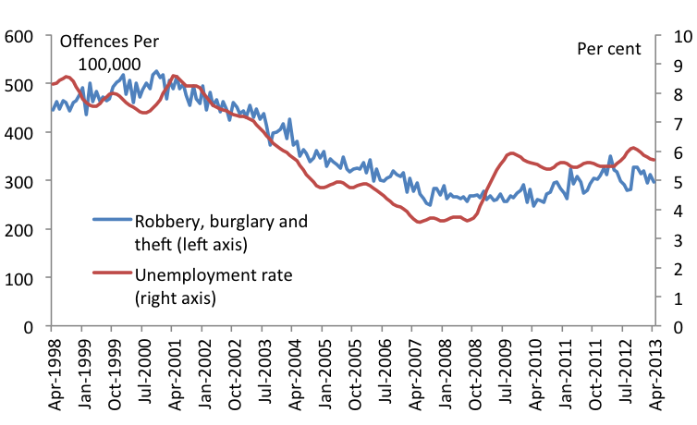
According to the statistics that they had collected it became visible that the crime rate in the US was going down despite the rising level of unemployment rate. According to the statistics that they used in their study, it can be correctly seen that while the level of unemployment was at an all-time high of 5.8% in the United States, the crime rate was at an all-time low at 5%. This study revealed that although there are people that engage in criminal activities because of their living standards, it is not the only reason why people engage in theft and crime. There are far many different reasons that make people engage in crime which is not related to the economic conditions of a person or a country.
According to the social cognitive theory that was written by (Tavory, 2015) in his research, he was able to find out that an individual becomes who is environment makes him to become. He seems to agree with what the advancer of the social cognitive theory who was called Albert Bandura had to say. According to him, if an individual has been brought up in an environment that is rough and which is full of rowdy individuals, they are likely to become what their environment is teaching them to become. According to him, an individual grows and becomes what his environment teaches them to become. According to the theory advanced by Bandura, kids who were brought up watching violent television shows, they are most likely to be violent when they grow up. Therefore according to Tavory, sometimes criminals do not engage in crime because they have to, but sometimes they do it because they think that it is cool by their standards and therefore, they engage themselves in criminal activities.
He gives an example of the Al Qaeda arm which before the death of their leader Osama Bin Laden used to threaten the United States and even in a number of times they were able to inflict damage on the citizens of the United States of America. In his study he investigates a former member of the group who states that, most of the people who were in Al Qaeda were learned individuals. These were people who could have been able to use their skills to gain meaningful employment and steer away from crime. However, the desire and the hunger of engaging in crime was more and they ended up joining Al Qaeda. He says that, while they were growing up they were made to believe that the US despises Muslims and therefore the people in the US did not have a reason to live. This led to the growth of hate for the US as a country and its citizens such that when they had to join Al Qaeda they did not have hard time thinking about it, because to them, they had a cause and they were willing to fight for that cause regardless.
This is the same situation according to (Day, 2015) in which he states that the rise in shooting in schools by teenagers is not because most of them come from homes that have financial difficulties, but rather they come from homes that did not make them grow very much individually in terms of character and personality. He says that if individuals can be given proper care then some of the issues that the modern youths of today are passing through would not be present. The lack of parental guidance and the rise in popularity of violent video games are some of the few things that he attributes for the rise in number of people who are juveniles and those that end up in crime while they are still young as well as the rise in number of single families. This is an issue that more should be done to ensure that children grow into human beings who are responsible.
Conclusion
Based on the above analysis, it is correct to state that although the state of the economy and the financial situation of an individual can be able to drive the individual into conducting crime, it is not the only thing that can be able to make a person be into criminal activities. For this reason, an individual needs to be surrounded by positive energy because that is what determines the way and the direction that an individual takes in life. Parents should bring up their children well because in so doing they will create individuals full of character who would rather work hard when they lack instead of stealing.

References
Assink, M., van der Put, C., Oort, F., & Stams, G. (2015). The development and validation of the Youth Actuarial Care Needs Assessment Tool for Non-Offenders (Y-ACNAT-NO). BMC Psychiatry, 15(1). http://dx.doi.org/10.1186/s12888-015-0421-1
Day, A. (2015). Correctional Psychology and the Desistance Paradigm. Criminal Justice And Behavior, 42(1), 121-124. http://dx.doi.org/10.1177/0093854814550032
Ott, T. (2014). US law enforcement strategies to combat organized crime threats to financial institutions. Journal Of Financial Crime, 17(4), 375-386. http://dx.doi.org/10.1108/13590791011082742
Punyasavatsut, A. (2016). Determinants of the Weighted Crime Rate in Thailand. Journal Of Economics, Business And Management, 4(2), 161-165. http://dx.doi.org/10.7763/joebm.2016.v4.384
Seongsu Park, & Kim, Mi-Seon. (2012). A Study on Prediction of Recidivism by a Risk Assessment for Juvenile Offender at Police Investigation : The Specialist Participation System on Investigation of Juvenile Offenders. Journal Of Korean Public Police And Security Studies, 9(1), 27-47. http://dx.doi.org/10.25023/kapsa.9.1.201205.27
Tavory, I. (2015). Causality and the Cognitive. Journal For The Theory Of Social Behaviour, 46(1), 27-31. http://dx.doi.org/10.1111/jtsb.12082

